**Open Source Graphics And Animation tools**

**Practical File**

**(BLENDER)**

*Submitted to*

**Dr.Durgansh Sharma**

**Associate Professor, Cybernetics SCS, UPES**

*Submitted By*

Name: Harsh Narain Mathur

Roll No.: 20

SAP ID: 500069098

B. Tech CSE (OSSOS)Department of Cybernetics

COMPUTER SCIENCE & ENGINEERING

cid:1511675710.3638.14.camel@ddn.upes.ac.in

**School of Computer Science**

**University of Petroleum and Energy Studies,**

**Dehradun – 248007: Uttarakhand**

**January 2020**

CONTENT: 1

EXPERIMENT-5 1

**AIM:** Design of 3D Text using Blender 1

EXPERIMENT-6 1

**AIM:** Design of 3D Hut using Blender 1

EXPERIMENT-7 1

**AIM:** Design of 3D Rocket using Blender. 1

EXPERIMENT-8 1

AIM: Design of 3D Mountain using Blender 1

## EXPERIMENT-5

### **AIM:** Design of 3D Text using Blender

**Steps:**

STEP-1:OPEN ADD OPTION AND SELECT TEXT.

STEP-2:THEN WRITE YOUR NAME IN PLACE OF IT.

STEP-3:THEN GO TO THE ALIGNMENT OPTION AND PUT IT IN CENTRE

STEP-4:GIVE A LITTLE BIT OF BEVEL OF 1M.

STEP-4:GO TO THE TOP VEIW AND THEN ADD A CIRCLE AND POINT.

STEP-5:GO TO CONTRAINT AND SELECT THE OFFSET ACCORDING TO THE FRAMES REQUIRED.

Step-6:MAKE THE TEXT METALLIC SO THAT IT WILL LOOK MORE PERFECT.

STEP-7:GO TO LIGHT PROPERTIES AND INCREASE THE POWER BY 100W AND SELECT THE COLOUR.

STEP-8:NOW FOR SHADING OPEN COLOUR RAMP FOR THE BRIGHTNESS.

STEP-9:ADD THE COLOUR BUMP AND ADJUST THE STRENGTH.

STEP-10:TURN ON THE BLOOM FOR THE BETTER VIEW.

OUTPUT IS READY.

**OUTPUT:**

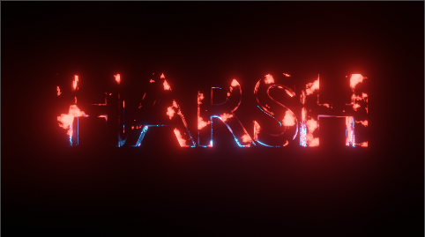

## EXPERIMENT-6

### **AIM:** Design of 3D Hut using Blender

**STEPS:**

STEP-1: FIRSTLY,ADD A CUBE HERE AND THEN MAKE A DUPLICATE ONE ABOVE IT.

STEP-2: START SCALING THE TOP CUBE BY S BUTTON AND X FOR LIMIT THE SCALING.

STEP-3 :SELECT THE VERTICES AND SCALE IT,DELETE THE DOUBLE VERTICES BY VERTEX SPECIAL MENU AND SELECT REOMOVE DOUBLES.

STEP-4: SELECT IT AGAIN TO GIVE EAVES TO THE ROOF AND SCALE IT BY X&Y AXIS ONLY.

STEP-5: FOR THE WINDOW,ADD A PLANE AND FACE IT FORWARD BY ROTATING 90 DEGREE AND SCALE IT DOWN BY 0.4.

STEP-6:FOR THE DOOR,CREATE A PLANE AND ROTATE IT TO FACE FORWARD AND ALIGN IT IN FRONT

STEP-7:FOR THE PAILING,ADD A PLANE AND SCALE IT TO THIN AND THEN EXTRUDE IT.

STEP-8:DUPLICATE THEM AND PUT IT HORIZONTALLY ALSO FOR TH HORIZONTALS BARS AROUNT THE HOUSE

OUTPUT IS READY

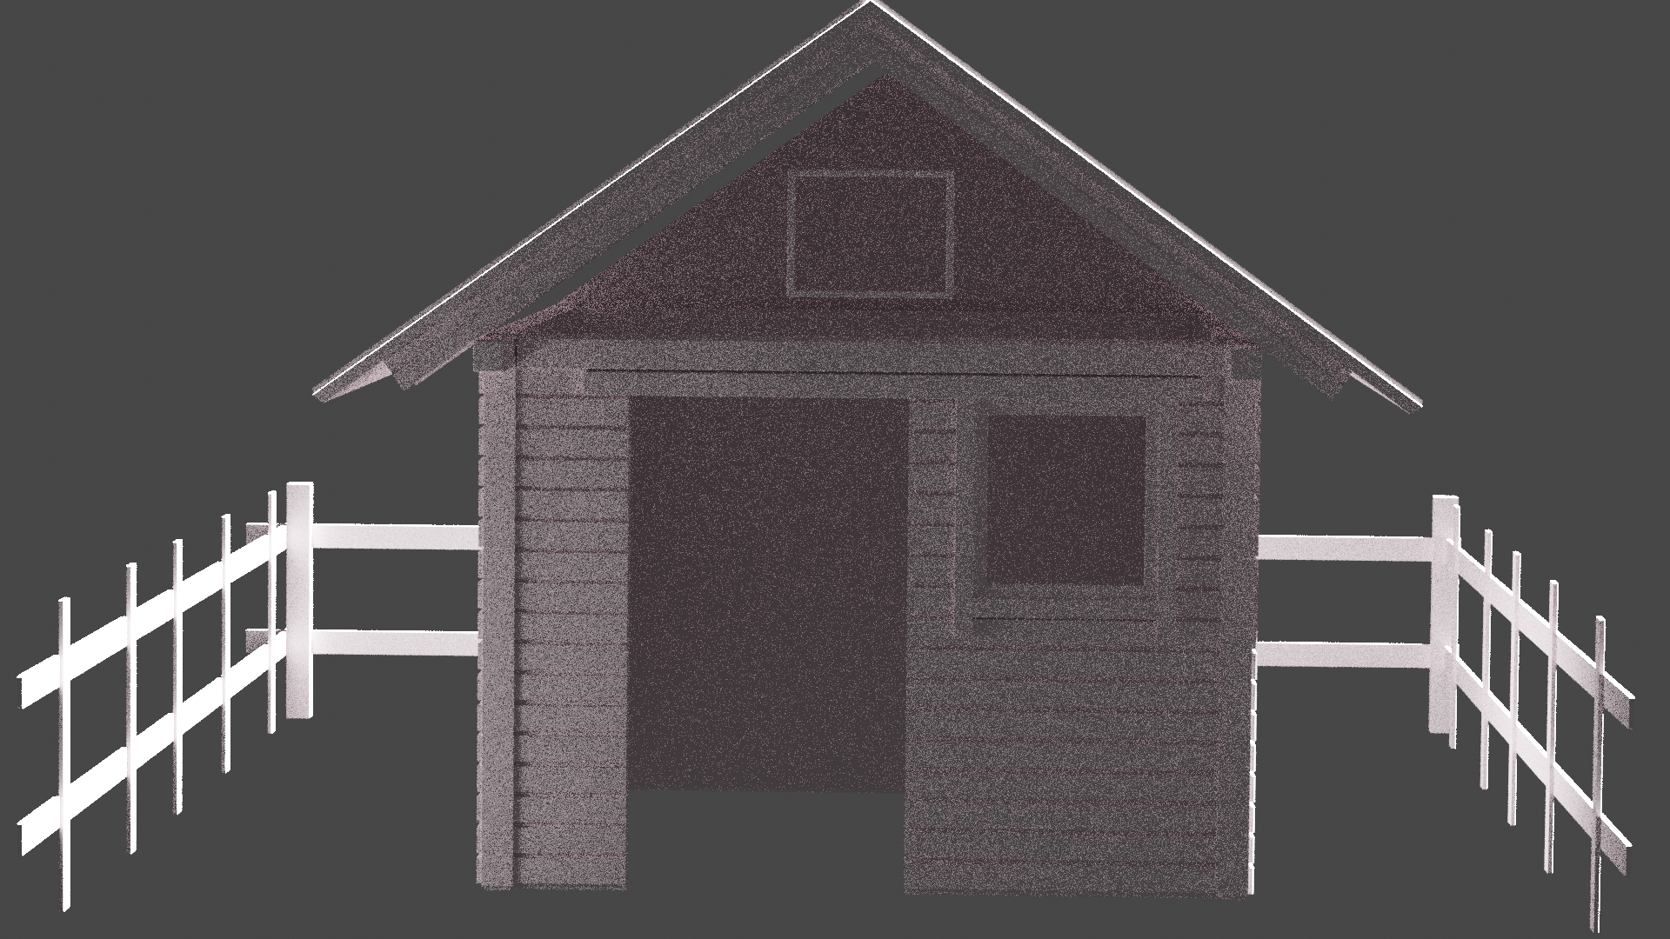

## EXPERIMENT-7

### **AIM:** Design of 3D Rocket using Blender.

**STEPS:**

STEP-1:FIRSTLY,ADD A CYLINDER FROM THE ADD AND MESH OPTION**.**

STEP-2:THEN EXTEND IT BY E BUTTON AND THEN SCALE IT TO GIVE AN OVAL SHAPE

STEP-3**:**FOR THE LAUNCHER BELOW SELECT THE INNER RING OF VETICES USING CIRCLE(C) AND THEN EXTRUDE THE EDGES.

STEP-4**:**EXTRUDE THEM ALONG Y-AXIS FOR BETTER MEASUREMENTS.

STEP-5**:**FOR THE OVAL LAYER ATTACHED TO THE TOP OF ROCKET USER THE EDGE LOOP CUT TOOL NA DTHEN USE THE EXTEND OPTION TO BE IT MORE VISIBLE.

Steps-6**:**FOR THE BLADES OF ROCKET,USE THE CUBE AND SELECT THE VERTICES TO GIVE TH SHAPE.

Steps-7**:** Use SHIFT+D button to get the the same type of blades.

STEP-8**:** FOR THE COLOUR,GO TO THE MATERIAL PROPERTIES AND START GIVING THE BAS COLOUR TO RACH MATERIAL USED.

STEP-9**:** ADJUST LITTLE BIT OF ROUGHNESS ACCORDING TO THE MATERIAL**.**

STEP-10**:** ROCKET IS READY**.**

**OUTPUT:**

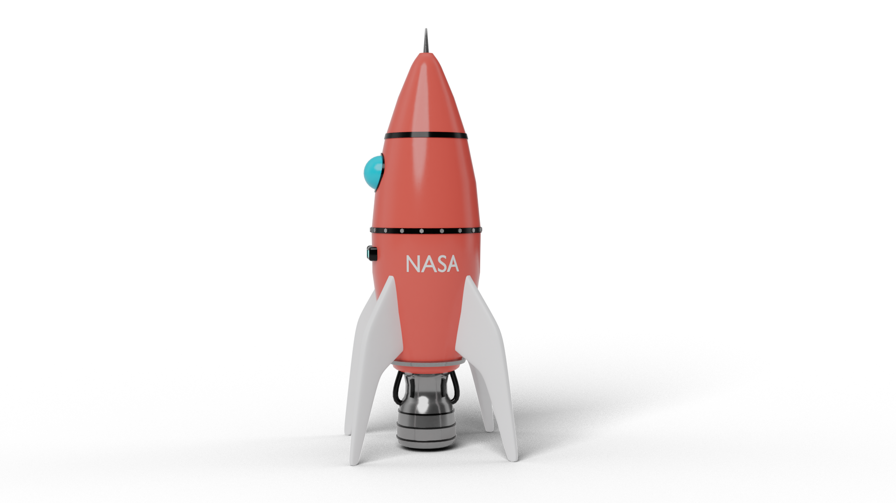

## EXPERIMENT-8

AIM: Design of 3D Mountain using Blender.

STEPS:

STEP-1:FIRSTLY,GO TO EDIT OPTION AND SELECT PREFERENCES.

STEP-2:SELECT THE ADD-ON OPTION AND SEARCH FOR THE 3D VIEW OF MOUNTAIN.

STEP-3:ONCE THE MOUNTAIN IS CFREATED,GO TO MATERIAL PROPERTIES.

STEP-4: ADJUST THE DEPTH.CONTRAST AND SHARPNESS OF THE MOUNTAIN.

STEP-5:GO TO THE TEXTURE PROPERTY AND SELECT THE APPROPRIATE TEXTURE ACCORDINGLY AND CAN DOWNLOAD IT FROM INTERNET.

STEP-6:USE CAMERE VIEW AND CAN SEE THE FOLLOWING OBJECT.

STEP-7: OUTPUT IS READY.

**OUTPUT:**

